Aidan Jeremy Yu Uy 11/12/25

Properties
- Root
- The top most node or beginning of the tree
- Siblings
- Children that directly share the same parent
- Path
- The sequence of connections across nodes
- Ancestor
- Any parent present in the tree
- Descendant
- Any child present in the tree
- Subtree
- A part of the tree that contains a node and all of its descendants
- Height
- The distance going from bottom to top
- Depth
- The distance going from top to bottom
- Parent
- The direct node above the child/children
- Children
- The direct node/s below the parent
- Leaf
- Child nodes who do not have their own child node/s
- Cousins
- Child nodes who share the same grandparent node (which are parent nodes who directly connect to their same parent node)

DFT - Depth-First Traversal
BFT - Breadth-First Traversal

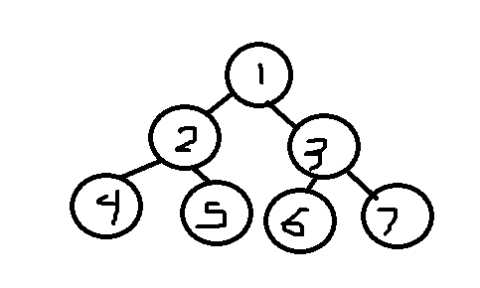
In order: 4, 2, 5, 1, 6, 3, 7
Pre-order: 1, 2, 4, 5, 3, 6, 7
Post-order: 4, 5, 2, 6, 7, 3, 1

